24.51: If the plates are pulled out as in Problem 24.50 the battery is connected, ensuring that the voltage remains constant. This time we find:
a) 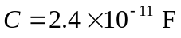 b) 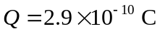 c) 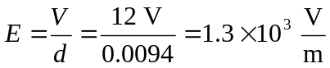

d) 